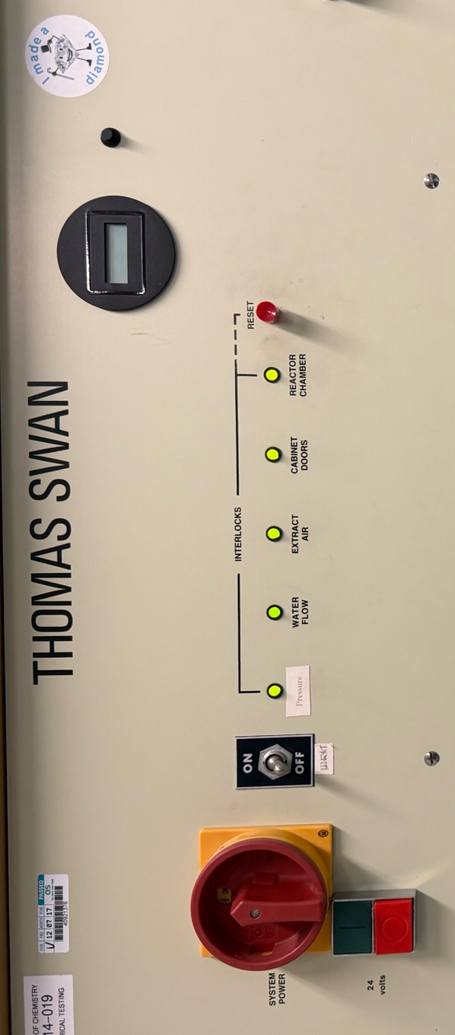
Thomas Swan Interlock Test Routine
A fully active interlock system can be observed above, with 5 green lights indicating each respective interlock is both active and or that component is running.

To reset the interlock light to green press ‘RESET’ then the green button below system power, this remains applicable to all interlocks during the cycle.

- The interlock labelled ‘WATER FLOW’ can be tested post growth run, under vacuum, prior to wire removal. The cycle should proceed as follows, water flow should be turned on via the chiller, the reaction heater should then be turned on by turning the key to ‘TS’ and pressing the green button observing the red light turning on. Leave this on for a few seconds then turn off the water flow at the chiller. Observe the green ‘WATER FLOW’ light turn off and the reactor heater bulb also turn off, showing the interlock is active in disabling all heating components.

Please note this cycle does not confirm deactivation of power to the filaments. This should be tested periodically but not during loaded wire runs, due to risk of filament snapping and damaging wires.

- Pumping down the chamber requires the vacuum valve to be closed as following the regular standard operating procedure. Opening the cabinet can initially confirm the operation of the ‘CABINET DOORS’ interlock. Observe when opening the cabinet door, the green light turn off, followed by a click indicating the argon valve opening and methane and hydrogen valves closing. The light next to the argon flow meter should turn green. This will be retested later to visually confirm the closing of methane and hydrogen valves.

- Following this, ensure the vacuum valve is now closed, close the cabinet door and observe the reactivation of the ‘CABINET DOORS’ interlock to red, this can now be reset.

- Reintroduce air to the chamber as standard, slowly turning the handle from vacuum, to close, to atmosphere. During this, the “Pressure” interlock should trip as pressure exceeds the 100 Torr set point and approaches atmospheric pressure. Remove the 3 bolts holding the chamber lid in place and lift the chamber lid using the pneumatics system. Observe the full deactivation of the ‘REACTOR CHAMBER’ light, indicating the lid is not in place on the reactor body. Following the necessary work being completed, lower the lid using the pneumatics system and confirm the reactivation of the ‘REACTOR CHAMBER’ light. Replace bolts and pump down the vacuum as standard.

- Once pumped down to an adequately low pressure, ensure the gas valves on the wall are closed then open the hydrogen and methane gas valves on the reactor. Observe green lights on next to the methane and hydrogen flow meters. Following this, open the lower cabinet door, this time observing: the green light on the ‘CABINET DOOR’ interlock turn off; an audible click of the argon gas valve opening and the methane and hydrogen gas valve closing; the green light next to the argon gas valve turning on and the green lights next to the methane and hydrogen gas valves turning off. This will confirm full operation of the ‘CABINET DOOR’ interlock in shutting and opening gas valves.

Please note this step will almost definitely result in outgassing, leading to a pressure spike, hence it is advised that this step is carried out a few hours before runs to allow time for pressure to readjust.

- Once pumped down, re-run the ‘WATER FLOW’ cycle test. Turn on water cooling via the chiller, observing the red interlock light turn on (reset to green), then turn on reaction heater with the key turned to ‘TS’ and pressing the green button, observing the red heater light turning on. Turn off water flow and observe the ‘WATER FLOW’ interlock light turn off and the reaction heater light turn off.

Please note – the wire carousels will likely be loaded and filament put in place during this second test. To avoid the risk of any filament damage, do not connect filament power lines to the chamber lid before this test.

- ‘EXTRACT AIR’. Should remain on at all times, If the light is off, seek assistance and do not run the reactor.

